With FDA decision looming, bipartisan group of lawmakers urge support for MDMA to treat PTSD

By AnneClaire Stapleton, CNN
5 minute read
Published 7:14 AM EDT, Mon August 5, 2024
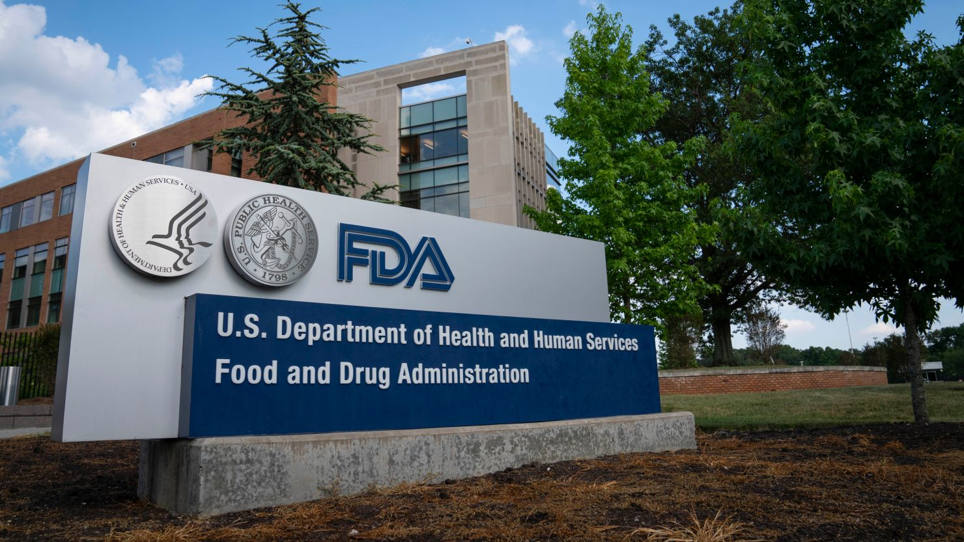
A sign for the Food And Drug Administration is seen outside its headquarters on July 20, 2020, in White Oak, Maryland.
Sarah Silbiger/Getty Images
CNN —
In a show of bipartisanship, 80 members of Congress from both sides of the aisle have united in letters urging President Joe Biden and the US Food and Drug Administration to further consider studies on MDMA-assisted therapy for post-traumatic stress disorder — an effort that aims to expedite access to a treatment they hope could help veterans.
The coordinated effort is a call for action from the highest levels of government to provide relief to millions of people experiencing PTSD amid a dramatic rise in veteran suicides.
“Our country has a severe veteran suicide and PTSD crisis where 6,000 veterans die by suicide each year, with over 150,000 suicides since 9/11,” the Senate letter to FDA Commissioner Dr. Robert M. Califf states. “As a nation, we cannot allow our veterans to continue to suffer in silence and must identify treatments proven to drastically decrease the adverse effects of PTSD. … The potential for groundbreaking advancements in PTSD treatment is within reach, and we owe it to our veterans and other affected populations to review these potentially transformative therapies based on robust clinical and scientific evidence.”
About 5% of adults in the United States — some 13 million people — experience PTSD in any given year, according to estimates from the National Center for PTSD. But current treatment options — including antidepressants and some specialized forms of cognitive behavioral therapy — are limited in their scope and effectiveness, with few alternatives available to help those who don’t respond well to them.
One letter is signed by 61 House members and led by Michigan GOP Rep. Jack Bergman, a retired three-star USMC general and the highest-ranking combat veteran in Congress. It is addressed to Biden and copies the secretaries of the Department of Health and Human Services and the Department of Veterans Affairs.
Nineteen senators, led by Colorado Democrat Michael Bennet and North Carolina Republican Thom Tillis, addressed their letter to Califf.
The House letter says there has been an “astounding lack of innovation the last nearly 25 years has contributed to rising veteran suicide rates. If the data and evidence show it’s safe and effective, we owe it to veterans to make this treatment option available.”
“We write today to express our sense of urgency to address the post-traumatic stress disorder (PTSD) and suicide epidemic among Veterans and servicemembers, and the grave need for new and better treatment options like MDMA-assisted therapy,” the letter to Biden reads.
The letters were sent as the FDA prepares to issue by August 11 a decision on MDMA, commonly known as ecstasy, to treat PTSD. The treatment is controversial and faces significant hurdles to approval: At a meeting in June, an independent group of advisers to the FDA raised questions about the integrity of the trial studying the treatment and missing safety data. Although “participants appear to experience rapid, clinically meaningful, durable improvement in their PTSD symptoms,” the FDA wrote ahead of the meeting, trial data were “challenging to interpret,” including because of bias in efficacy data. Only two of 11 experts advising the FDA said that they considered the treatment effective and only one committee member said that the benefits of the treatment outweigh the risks as presented. Although it’s rare for the FDA to go against its advisers’ recommendation, the agency has the final say.

close dialog


Sign up for CNN's What Matters newsletter
Every day we summarize What Matters and deliver it straight to your inbox.
Sign Me Up
No, Thanks
By subscribing you agree to our

privacy policy.

However, the FDA and its advisers acknowledged there’s a significant need for new and better options. No new therapies for PTSD have been approved in more than 20 years — a key point in the new letters.
Bipartisan support for MDMA-assisted therapy is gaining momentum after years of pushing from the veteran community, which sees hope in experimental therapies, including the MDMA-assisted therapy from Lykos Therapeutics that’s currently before the FDA.
The therapy is the first such treatment to reach this point in the regulatory process. MDMA is known as an entactogen, a class of psychoactive drugs that produce experiences of emotional communion, relatedness and emotional openness. It’s currently classified as a Schedule I drug under the Controlled Substances Act, and changing this status would be a marked shift.
“It is not our intent to urge the FDA in any direction related to its decision, which must be based solely on the data and evidence. However, we are aware that as this application has made its way through the regulatory review process, certain groups and individuals have voiced criticism of the application. It is our understanding that while these critics may be well-intentioned, their criticism is not necessarily reflective of the science, but rather their personal ideological beliefs and biases related to the medicalization of substances like MDMA,” the House letter says.
VA Under Secretary for Health Dr. Shereef Elnahal has said that current PTSD treatments would “pale in comparison” to preliminary results from MDMA-assisted therapy, if they’re able to be replicated, and psilocybin for treatment-resistant depression.
“The data and results, the stories that I have heard from veterans who have gone through these studies, these therapies speak for themselves,” Elnahal has said.
The VA has taken significant steps over the past months to prepare for the therapy’s potential rollout. This includes issuing a request for applications to assess MDMA-AT’s effectiveness for veterans and forming an integrated project team to handle the anticipated high demand from the veteran community. However, the VA’s ability to administer MDMA-AT hinges on FDA approval.
“If the data and evidence show that MDMA-AT is safe and effective at relieving the suffering that many Veterans face, then we owe it to them and the millions of others who are living with PTSD to make this treatment option available to them,” the House letter reads.
Another letter, co-authored by 14 veteran service organizations and 730 veterans, was published Monday in conjunction with the congressional letters. “We are confident that if MDMA-AT can be made sufficiently accessible, it will prove to be amongst the most invaluable treatments ever developed to combat the veteran suicide epidemic,” the veteran letter reads in part.

